**Design Document**

**Yichao Xu 201299092**

Index for the Design Document

1. Summary of Proposal 2

**1.1** **Brief Statement** 2

**1.2** **Summary of The Research and Analysis** 2

2. Project Design 3

**2.1 Use case diagram** 3

**2.2** **Architecture Design** 8

**2.3**  **Abstract Specification** 8

**2.4** **Interface Design** 9

**2.5** **Components Design** 11

**2.5.1** **Controller** 12

**2.5.2** **Model** 12

**2.6** **Data structure Design** 13

**2.6.1** **HashMap and List** 13

**2.6.1** **General Tree Node** 13

**2.7** **Algorithm Design** 13

**2.7.1** **Evaluation Algorithm** 13

**2.7.2** **Alpha-beta Pruning Algorithm** 14

**2.8** **Test Design** 15

**2.8.2** **Cluster Test** 15

**2.8.3 Class Test and Operation Test** 16

**2.9** **Evaluation Design** 16

**2.8.1** **self-evaluation** 16

**2.8.2** **3rd party Evaluation** 17

**2.8.3** **Evaluation Function** 17

3. Review against Plan Error! Bookmark not defined.

**1.1** **Previous** **Error! Bookmark not defined.**

**1.2** **Current** **Error! Bookmark not defined.**

4. Reference 18

**1. Summary of Proposal**

**1.1 Brief Statement**

As described in the specification document, “Risk” is a turn-based strategy board game for two to six players. Each player will have the fixed number of armies at the start of the game and will automatically receive additional army units in each turn [1]. Additionally, each player will be able to attack or ally with a territory controlled by opponent.

The project aim is to design, implement, test and evaluates a turn-based strategy game which is based on the rule of “Risk”, with the both intelligent agent players and the human players. This document of the project is prepared for the final year project supervisor and the players.

Additionally, the artificial intelligence algorithm is changed from the selection algorithm to a advanced searching algorithm

**1.2 Summary of The Research and Analysis**

The document designs the game program following the software engineering design process. At first, it describes the use cases of the game by a use case diagram with a dictionary to describe each use case.

Then, the document uses the context model to describes the architecture of all subsystems. The system will use the Model-View-Controller architecture pattern and the parallel controlling model.

In the abstract specification, the document discusses the details of these subsystem and the design patterns, such as the singleton, delegate and notification, will used in the system.

In the interface design, the document specifies a user interface of the game. the Unity asset “Earth-3D” will be used to generate the game map. In addition, the document provides the image of the game map which is automatically generated by the asset.

In the component design, the document uses the class diagram to describe the classes consisting of the system. Additionally, the document focuses on the design of the system model and system controller.

In the data structure design, the document describes the HashMap, LinkedList and an extension for the General Tree. And in the algorithm design, the document implements the evaluation algorithm and alpha-beta pruning algorithm.

In the test design, the document writes the possible test cases and in the evaluation design, it describes the details of the three evaluation methods in the specification document.

**2. Project Design**

This project will firstly describe the requirements in the project by the use case diagram and then it will follow the software design process, namely, architecture design, abstract specification, interface design, components design and algorithm design.

**2.1 Use case diagram**

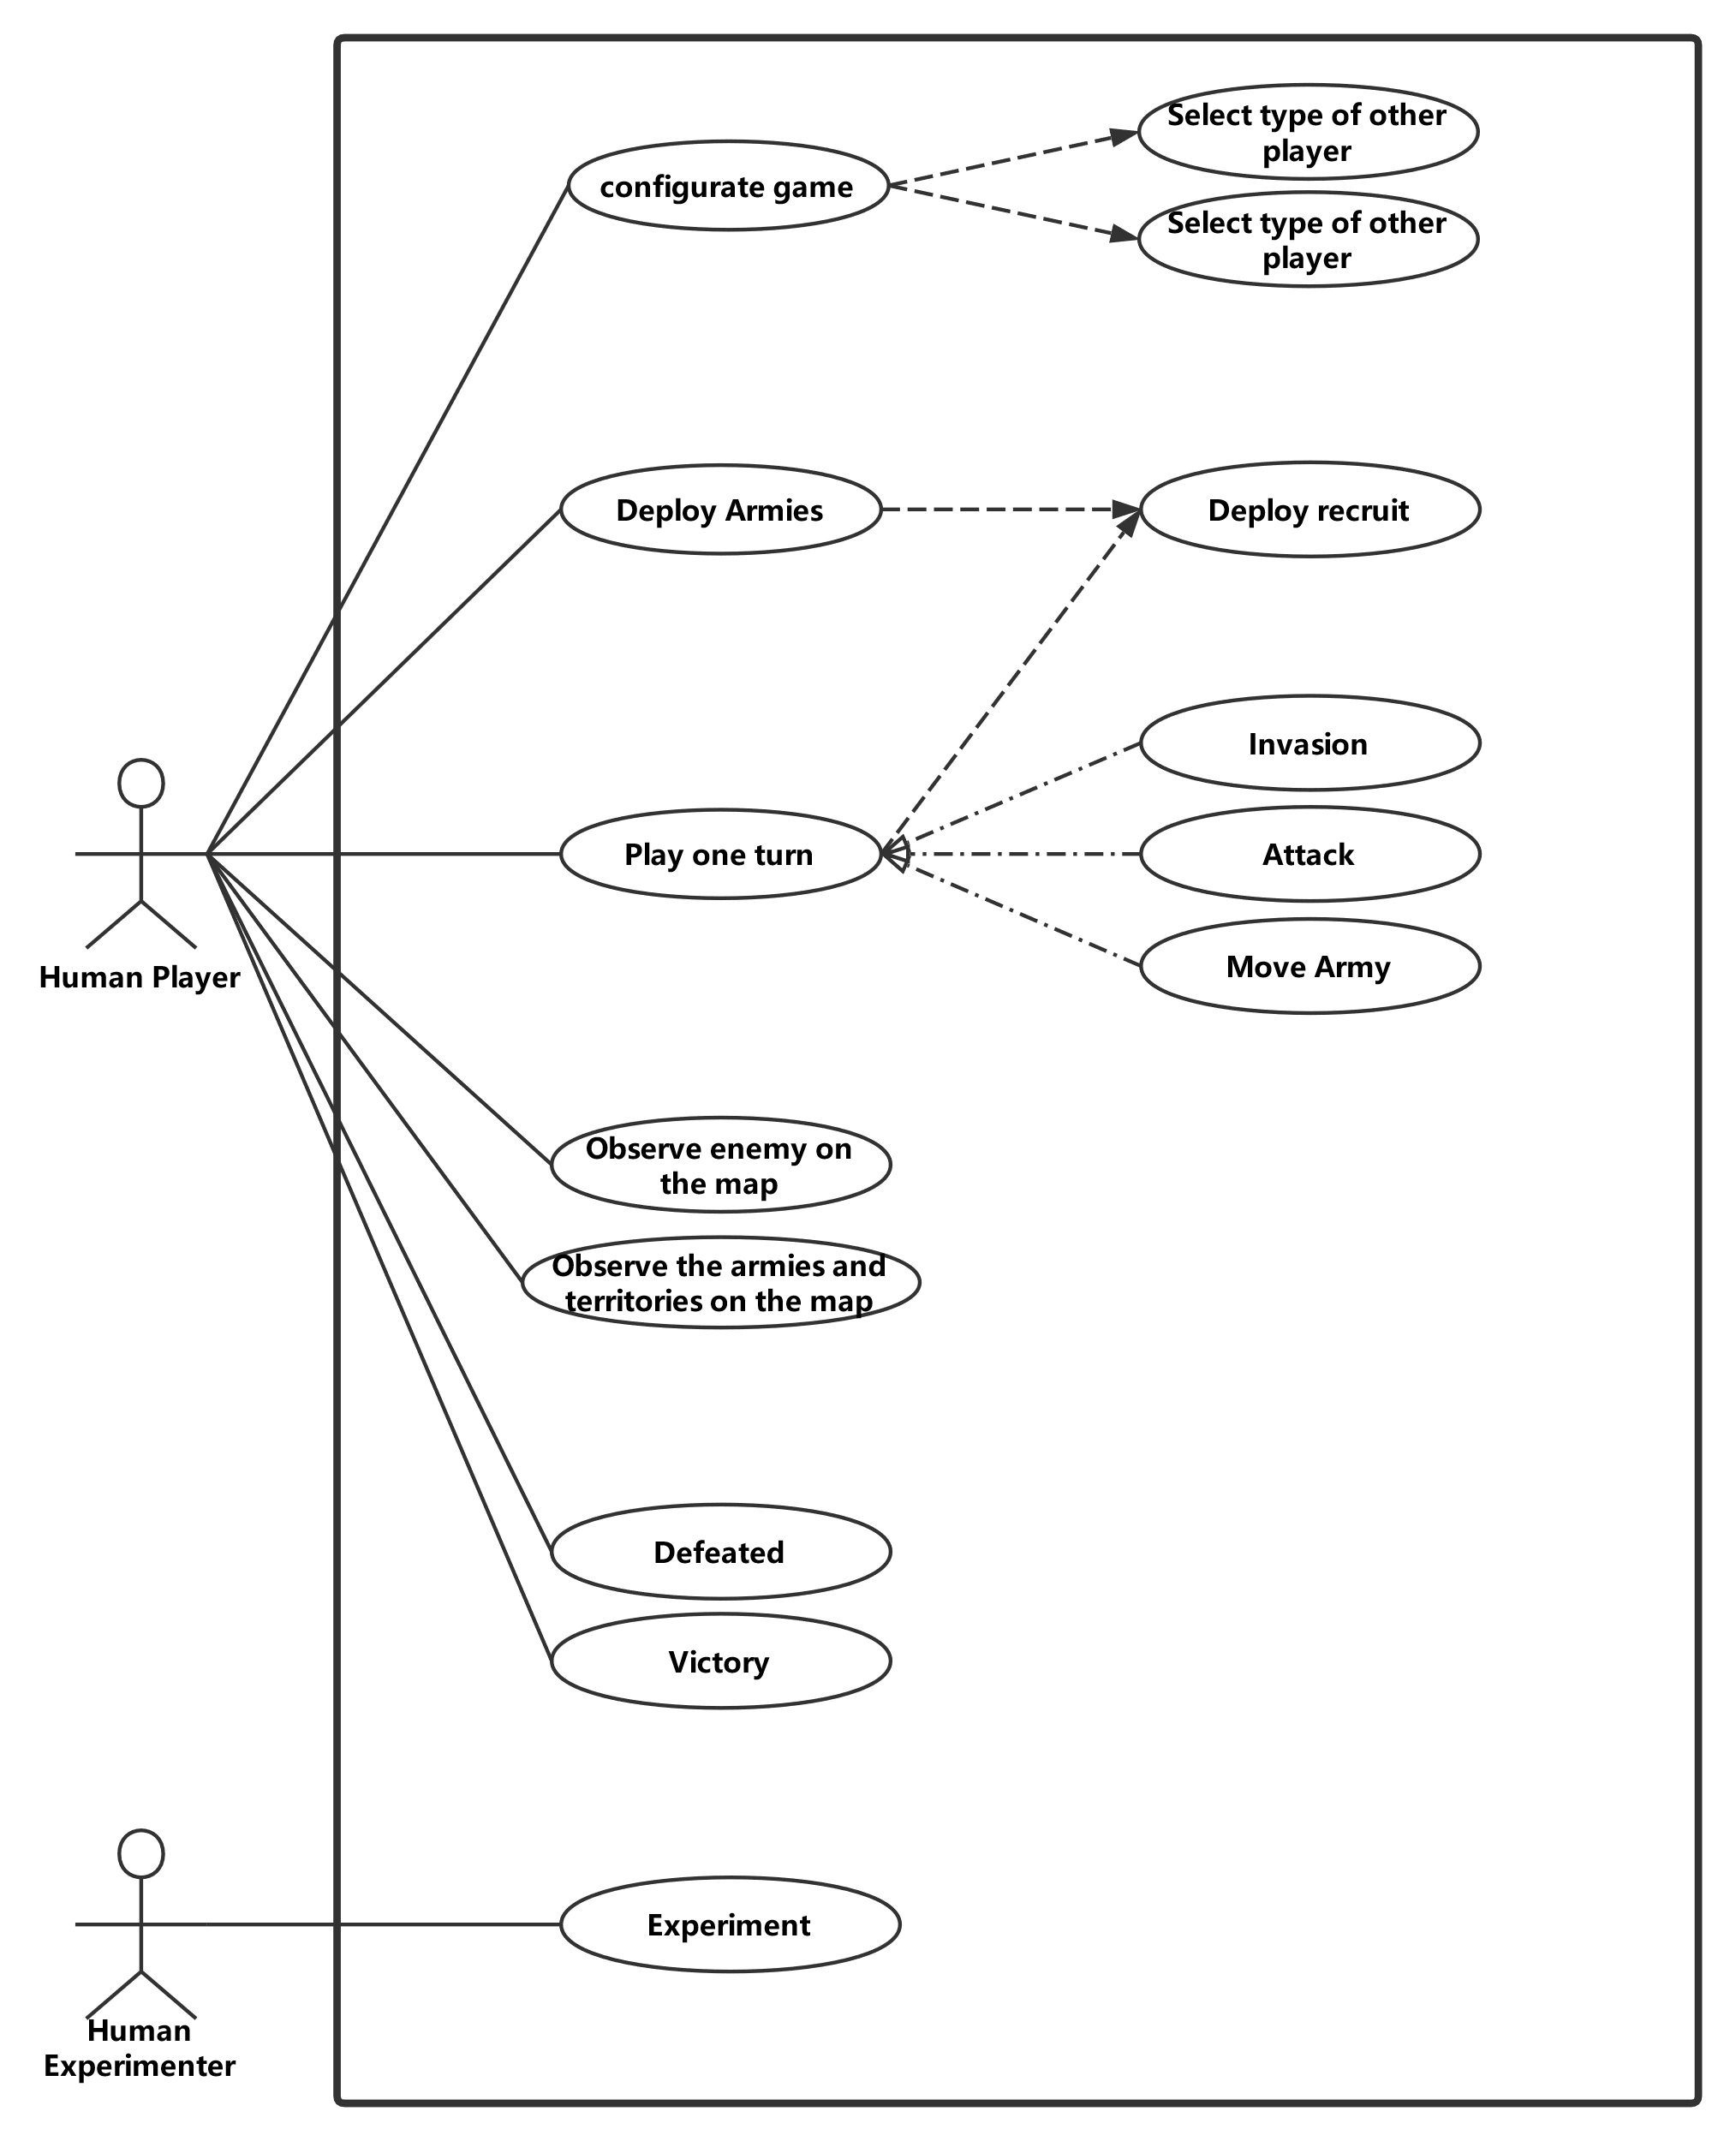

Figure 1 Use case Diagram

|  |  |
| --- | --- |
| **ID** | UC1 |
| **Name** | Configure game |
| **Description** | The user configures the game before starting a new game. |
| **Pre-conditions** | There is not any information about the number and the type of player. |
| **Event flow** | The game system shows the user a guide of configuration. include UC2() include UC3() Generate the game based on the data from UC1 and UC2 |
| **Post-condition** | The game has been generated according to the collected data. |
| **Includes** | UC2, UC3 |
| **Extensions** | None |
| **Triggers** | A game user click button “Start Game” |

|  |  |
| --- | --- |
| **ID** | UC2 |
| **Name** | Input number of the player |
| **Description** | The user input the number of the game player. |
| **Pre-conditions** | The system doesn’t know the number of players. |
| **Event flow** | At first, the game system requires the number of players from the user. After the user types a number, the system will check the validation. **if** it is valid,   the system will store the number of the player. **else**  the system will notify the user, the number is invalid. |
| **Post-condition** | The number of the player has been stored in the system. |
| **Includes** | None |
| **Extensions** | None |
| **Triggers** | A game user click button “Start Game” |

|  |  |
| --- | --- |
| **ID** | UC3 |
| **Name** | Select type of other players |
| **Description** | The user selects the type of another player in the game. |
| **Pre-conditions** | The system doesn’t store any information about other players  The system has stored the number of players. |
| **Event flow** | **for** all other players,  the user selects the player type from (human, simpleAI, normalAI, HardAI).  and then, it will be recorded in the system |
| **Post-condition** | The system has recorded the type of all players. |
| **Includes** | None |
| **Extensions** | None |
| **Triggers** | UC2 has been finished. |

|  |  |
| --- | --- |
| **ID** | UC4 |
| **Name** | Deploy Armies |
| **Description** | The human player deploys its armies at the start of the game. |
| **Pre-conditions** | A player doesn’t deploy the armies and the game is still in the configuration phase. |
| **Event flow** | **for** each recruit in the configuration phase  include UC5() |
| **Post-condition** | The player doesn’t have undeployed armies. |
| **Includes** | UC4 |
| **Extensions** | None |
| **Triggers** | The configuration turn of the player starts. |

|  |  |
| --- | --- |
| **ID** | UC5 |
| **Name** | Deploy recruit |
| **Description** | A human player deploys its recruit on the map. |
| **Pre-conditions** | The player has an undeployed recruit and in the recruiting phase. |
| **Event flow** | select a province on the map **if** it has already been occupied by the player,  the number of the armies on the province plus one. **if** it has already been occupied by another player,  abort the deployment. **if** it is unoccupied,  allocate the province to the player   set the number of armies on the province to be one. |
| **Post-condition** | The size of the player’s armies plus one. |
| **Includes** | None |
| **Extensions** | None |
| **Triggers** | The player clicks the allocate button. |

|  |  |
| --- | --- |
| **ID** | UC6 |
| **Name** | Invasion |
| **Description** | A human player’s armies invade the other player’s territory. |
| **Pre-conditions** | One of the player’s armies is on the boundary and in the attack phase. |
| **Event flow** | The user selects an army on the boundary. After that, move the army into an enemy’s province which is ungarrisoned Then, the player occupies the province. |
| **Post-condition** | The number of the player’s provinces plus one |
| **Includes** | None |
| **Extensions** | None |
| **Triggers** | The player drags an army on the belligerent’s ungarrisoned province |

|  |  |
| --- | --- |
| **ID** | UC7 |
| **Name** | Attack |
| **Description** | A human player’s one of the armies attacks the enemy and in the attack phase. |
| **Pre-conditions** | One of the player’s armies is nearby the enemy. |
| **Event flow** | The user selects an army on the boundary. After that, move the army into an enemy’s province which is garrisoned Then, the system calculates the result of the battle The armies of the defeated party will be annihilated The province will be occupied by the winner. |
| **Post-condition** | One of the belligerents’ armies on the province is annihilated |
| **Includes** | None |
| **Extensions** | None |
| **Triggers** | The player drags an army on the belligerent’s garrisoned province |

|  |  |
| --- | --- |
| **ID** | UC8 |
| **Name** | Move Army |
| **Description** | A human player moves the army between own provinces. |
| **Pre-conditions** | The number of the army of the player is not zero and the player is in the attack phase |
| **Event flow** | The user selects an army. After that, move the army into an own province Then, the number of the garrison plus one. |
| **Post-condition** | The allocation of the player’s armies is changed |
| **Includes** | None |
| **Extensions** | None |
| **Triggers** | The player drags an army on the belligerent’s garrisoned province |

|  |  |
| --- | --- |
| **ID** | UC9 |
| **Name** | Play one turn |
| **Description** | A human player plays one turn of the game. |
| **Pre-conditions** | The player doesn’t be defeated. |
| **Event flow** | The game turn starts. the player enters the Deploy Phase,  **for** each recruit do  include to UC5(); **for** each army in the map do  **if** the user decides to invade  include to UC6();  **if** the user decides to attack  include to UC7();  **if** the user decides to move  include to UC8(); end the game turn |
| **Post-condition** | The player ends the turn. |
| **Includes** | None |
| **Extensions** | UC5, UC6, UC7, UC8 |
| **Triggers** | The player turn starts. |

|  |  |
| --- | --- |
| **ID** | UC10 |
| **Name** | Observe enemy on the map |
| **Description** | A human player observes the location and the number of armies or provinces of other players. |
| **Pre-conditions** | The player currently doesn’t be defeated. |
| **Event flow** | Observe provinces and armies on the map. |
| **Post-condition** | The player has observed the enemy. |
| **Includes** | None |
| **Extensions** | None |
| **Triggers** | The player is going to observe the enemy. |

|  |  |
| --- | --- |
| **ID** | UC11 |
| **Name** | Observe own armies and provinces |
| **Description** | A human player observes the location and the number of own armies or provinces. |
| **Pre-conditions** | The player currently doesn’t be defeated. |
| **Event flow** | Observe provinces and armies on the map. |
| **Post-condition** | The player has observed own armies and province. |
| **Includes** | None |
| **Extensions** | None |
| **Triggers** | The player is going to observe own armies and provinces. |

|  |  |
| --- | --- |
| **ID** | UC11 |
| **Name** | Victory |
| **Description** | A human player wins the game. |
| **Pre-conditions** | The player is the last player of the game. |
| **Event flow** | The game system find that player is the last player of the game. After that, the system shows an information to notify the player. |
| **Post-condition** | The game is over, or the player is removed from the game. |
| **Includes** | None |
| **Extensions** | None |
| **Triggers** | UC2 require remotely authenticated service |

|  |  |
| --- | --- |
| **ID** | UC12 |
| **Name** | Defeated |
| **Description** | A human player is defeated. |
| **Pre-conditions** | The number of the player’s armies and provinces is zero. |
| **Event flow** | The player’s last province has been occupied by an enemy. The system checks the number of human players. **if** the number is zero,  Game over and conclude the result of the game; **else** game continues,  but the player will be removed from the game; |
| **Post-condition** | The game is over, or the player is removed from the game. |
| **Includes** | None |
| **Extensions** | None |
| **Triggers** | UC2 require remotely authenticated service |

|  |  |
| --- | --- |
| **ID** | UC13 |
| **Name** | Experiment |
| **Description** | A human experimenter to exam the AI system. |
| **Pre-conditions** | The game system is running. |
| **Event flow** | The experimenter clicks the “Simulating” button on the main menu.  The experimenter decides types of two computer players. The system automatically generates and logs the result of the game. |
| **Post-condition** | The game is over, and the game log has been produced. |
| **Includes** | None |
| **Extensions** | None |
| **Triggers** | The experimenter clicks the “Simulating” button on the main menu. |

**2.2** **Architecture Design**

The design pattern, Model-View-Controller, will be used in the project as the architecture design pattern. The subsystem of the game will be the “User Interface System”, “Game Control System”, “Game Model”, “Artificial Intelligence System” and “Notification Centre”. Additionally, the controlling model should be the “Parallel Model”.

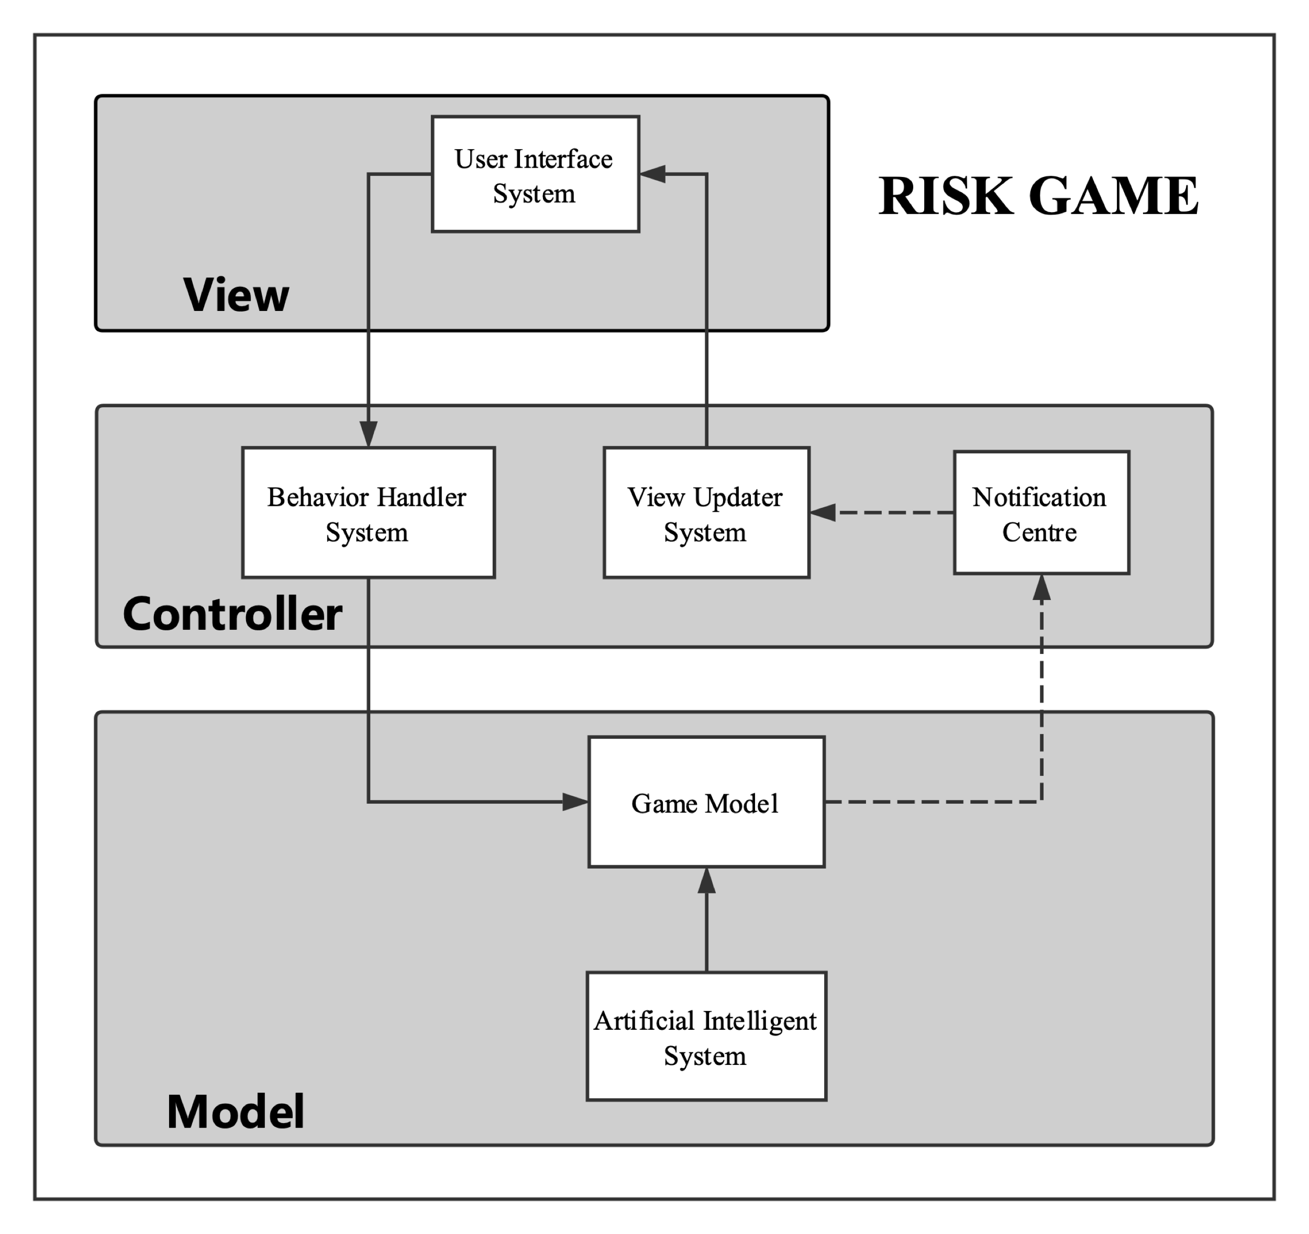

Figure 2 Context Model of Risk

**2.3 Abstract Specification**

The “User Interface System” is the game view. The subsystem contains all user interface components such as “button”, “game map” and “army icon”. When the user interacts with (clicks or drags) these components, the subsystem will send a message to the “Behavior Handler System”.

The “Behavior Handler System” is a part of the game controller. They should consist of a set of the Unity scripts which bind with game components in the user interface system. When the subsystem receives a message from the user interface system, it will send a message to the “Risk Game Model”.

The “Game Model” is the game model for handling the player’s action (from the human or computer player). It can receive messages from either the behavior handler system or the artificial intelligence system. After that, the subsystem will update the game model and send the changes to the “Notification Centre”. The “Artificial Intelligence System” is similarly a part of the game model. It will generate a series of actions by a minimax algorithm and deliver these actions to the game model.

The “Notification System” is a part of the controller. It will receive data from the game model and then, generate a series of notifications. After that, the subsystem will broadcast these notifications to the “View Updater System”

The “View Updater System” is a part of the game controller and it similarly consists of a set of the Unity scripts. The system will periodically check the broadcasted notification to update components in the game view.

**2.4 Interface Design**

In this part, the document will describe the design of the game user interface. The user interface of the game will consist of two parts namely, the game map and the game functional components.

The game map will show the player the provinces, continents, armies and enemies. In this project the “Earth-3D Asset” from the “Unity Assets Store” will be used. The asset will automatically generate a world map which is divided into series provinces as the figure3.





Figure 3 Game Map [2]

The game functional component is the component in the game which provides different functions to the player. As shown on the figure4, the game functional components of the game are three buttons and a text field on the top of the screen.



Figure 4 Functional Component

The text field shows the current turn of the game and the three buttons are the tools for making the game UI more user-friendly. The “NEXT” button will end the current player’s game turn and move to the next human player’s turn. The “ATTACK” button will highlight the boundary of the player and the “RECRUITS” button will highlight the player’s provinces.

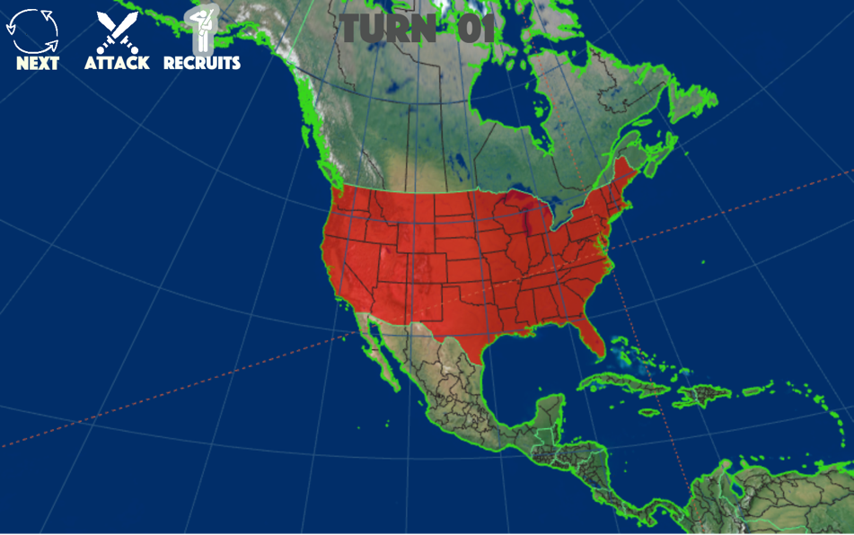

Figure 5 Activate the button "RECRUITS"

**2.5 Components Design**

­­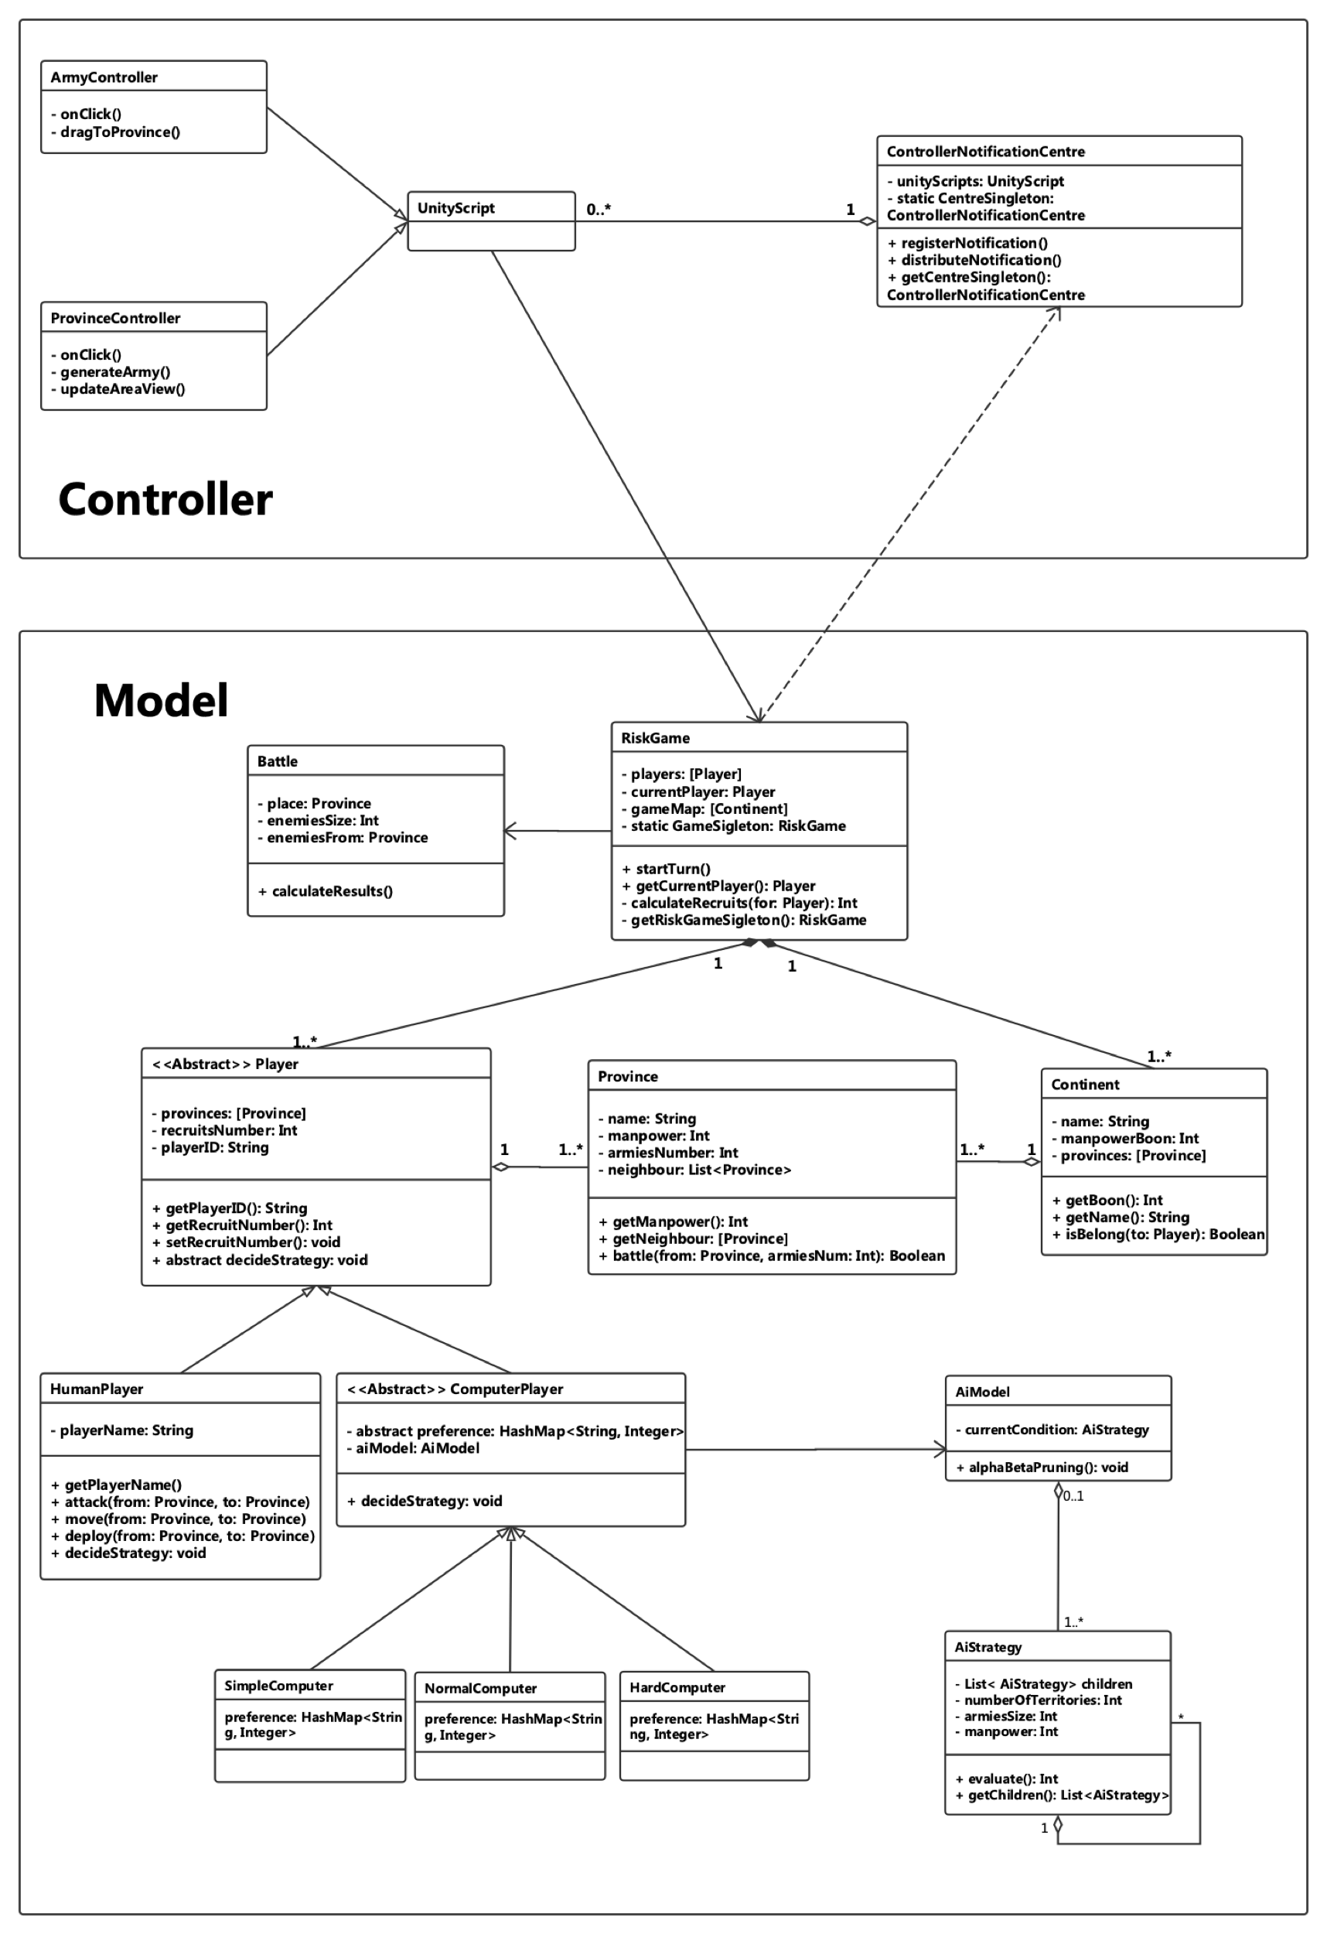

Figure 6 The class diagram

### **2.5.1 Controller**

In the system, the controller consists of the Unity-script and notification centre’s instances.

The basic Unity-script class provides two different functions: firstly, it will provide a group of interfaces for system components, such as the button, to handle the user behaviours; secondly, these Unity-scripts implements the delegate pattern, the Unity engine will periodically (per frame) invoke the method of the Unity-script. Therefore, in the project, both of the behaviour handler system and view updater system consist of the Unity-script’s instances. They will invoke the game model’s methods after receiving a message from the user interface system and update the game view after receiving a notification from the notification system. Additionally, both of the “Army Controller” and “Province Controller” inherit the Unity-script class. Two classes will handle the behaviour of the player for the armies and provinces on the game view respectively.

“Notification Centre” implements the observation and singleton pattern and it is the implementation of the notification system. It will receive data from the game model system and broadcast a notification to these Unity-scripts (All instances of Unity-script shall register itself into the system).

### **2.5.2 Model**

The system model includes the instances of “Risk Game”, “Battle”, “HumanPlayer” and “ComputerPlayer”, “Province” and “Continent”.

The “Risk Game” class will be the interface of the game model. Its public methods will be invoked by the Unity scripts and it will automatically send the result to the notification centre. It contains all continents on the game map and all players of the game.

The battle class represent a battle of the game. It stores the location and size of the battle and provides an interface to calculate the result.

The “Player” class represents a game player. It is an abstract class which describe all possible behaviours of a player namely, “move armies”, “deploy recruits” and “attack enemy”. Additionally, the class stores some information of a player such as the player’s id and the number of the recruits.

The “Continent” class represents a specified area on the map. The class includes the name of the continent, the manpower boon when a player has occupied all of these provinces and the pointers of all provinces in the continent.

The “Province” class represents a minimum geographic unit of the game. The class includes a series pointer for the nearby provinces, the number of manpower, the province will produce in each turn and number of the armies deployed on the province. In addition, it will provide a method to calculate the result of a battle.

The “HumanPlayer” and the “ComputerPlayer” extend the “Player” class respectively. The “ComputerPlayer” class is an abstract class which describe how the computer player makes a strategy and constraints that all subclasses should implement their preference function. It contains an instance of the “AiModel” which will implement an algorithm for the game AI. The “SimpleComputer”, “NormalComputer” and “HardComputer” class implement the class.

The “AiModel” is the core of the AI system. The class implement the alpha-beta pruning algorithm. It contains an instance of the “AiStrategy” which implement the general tree node and the evaluation algorithm.

**2.6 Data structure Design**

HashMap, LinkedList and GeneralTree will be used to implement the game

### **2.6.1 HashMap and List**

The HashMap will be used in the “NotificationCentre” to register the controller and similarly in the “ComputerPlayer” to store a preference function.

The List will be used in the class “RiskGame”, “Continent” and “Player”. In the “RiskGame”, two different Lists will be used to respectively store the continents and players of the game. And in both of the “Continent” and “Player” class, a List will be used to store instances of “Province” class.

### **2.6.1 General Tree Node**

The instances of the class consist of the tree structure. The tree nodes can have an arbitrary number of children and it provides a method to access all children of the node.

class GeneralTreeNode {

private List< GeneralTreeNode> children;

}

*Code 01: The design of the abstract class General Tree.*

In the project, the class “Strategy” will extend the GeneralTreeNode. It contains a series of pointers for all possible strategies and provides a method to evaluate the result of these strategies. It also contains a set of attributes which will be used for evaluation.

class Strategy {

private List< Strategy> children;

private HashMap<String, Integer> attributes;

public int possibleNextStrategies(){}

public int evaluate(Strategy strategy){}

}

*Code 02: The design of the Strategy class.*

**2.7 Algorithm Design**

The project will use a kind of adversarial search algorithm to implement the intelligence agent. The system algorithm design focuses on two different parts namely, the alpha-beta pruning algorithm design and the evaluation algorithm design.

### **2.7.1 Evaluation Algorithm**

The evaluation algorithm will value the player’s strategy in a game turn. the project will use the following expression to generate the evaluation algorithm.

$$Eval=w_{1}× F_{1}+ w_{2}× F_{2}+…+ w_{n}× F_{n}$$

*Function01: the expression for the evaluation algorithm* [3]

The expression contains two kinds of different variables: the variable $F_{n}$ represents a function to transfer a parameter in the game into a value and the variable $w_{n}$ represents the weight of the parameter. Therefore, the evaluation function will describe the value to a series of parameters and their weights.

As shown in Table01, the evaluation method will contain three different parameters

|  |  |  |
| --- | --- | --- |
| **Parameter** | **Function** | **Preference (weight)** |
| Territory | Return number of the territory | 2 |
| Army | Return size of the army | 3 |
| Manpower | Return value of the manpower | 2.5 |

Table 1 The function and weight for the risk game parameters in an evaluation function

Therefore, the design for the evaluation function will be:

public function eval(List<Province> territory, Int sizeOfArmy, Int manpower){

return preferences.get("Territory") * territory.size()

+ preferences.get("Army") * sizeOfArmy

+ preferences.get("Manpower") * manpower;

}

*Code 03: The design of evaluation algorithm*

### **2.7.2 Alpha-beta Pruning Algorithm**

The alpha-beta pruning algorithm will be used in the project to produce the strategy based on the results of the evaluation algorithm.

The Code04 is a pseudo code for the alpha-beta algorithm. In the pseudo code, the parameter strategy is a node of a general tree which stores all possible strategies of the player. The parameter depth will identify the depth of the DFS. Two parameters α and β are used to cut off the subtree and they store the maximum and minimum value of the current strategy. The Boolean value, isMyTurn, is used to identify the player and it will change the behaviour of the algorithm.

int alphaBeta(Strategy strategy, int depth, int α, int β, boolean isMyTurn){

if depth = 0 or the gameover, then

return eval (node)

if isMyTurn, then

value := −∞

for each strategy in strategy. possibleNextStrategies do

valueOfNextStrategy := alphabeta(child, depth − 1, α, β, false)

value := Math.max(value, valueOfStrategy)

α := Math.max(α, value)

if α ≥ β then break (cut-off)

return value

else it is enemy’s turn

value := +∞

for each strategy in strategy. possibleNextStrategies do

valueOfNextStrategy := alphabeta(child, depth − 1, α, β, false)

value := Math.min(value, valueOfStrategy)

β := Math.min(β, value)

if α ≥ β then break (cut-off)

return value

}

*Code 04: The design of alpha-beta algorithm* [4]

**2.8 Test Design**

As described in the specification document, the project will use the object-oriented testing to test the program and will strictly follow a top-down integrate testing process, namely, operation test, class test, cluster test, system test.

**2.8.1 System Test**

At first, the black-box test will be used to test the whole system. The test case in the phase will rely on the use cases as shown in the following tables.

|  |  |
| --- | --- |
| **Title** | Configure game |
| **Description** | A user configure the number and type of the game player |
| **Match use case** | UC1, UC2, UC3 |
| **Test Steps** | The game system requires the number of players from the user. After the user types a number, the system will check the validation. **if** it is valid,   the system will store the number of the player. **else**  the system will notify the user, the number is invalid. and then **for** all other players,  the user selects the player type. |
| **Expected Result** | Game start with the correct number and type of players. |

|  |  |
| --- | --- |
| **Title** | Play One Turn |
| **Description** | A human player plays one turn of the game. |
| **Match use case** | UC5, UC6, UC7, UC8, UC9 |
| **Test Steps** | The game turn starts with 3 recruits. the player enters the Deploy Phase,  **for** each recruit do  test the recruit behaviours test the attack behaviours  test the move behaviours  test the invasion behaviours end the game turn |
| **Expected Result** | The player ends the turn and both of the locations of the player and results of the battle are correct. |

|  |  |
| --- | --- |
| **Title** | Victory |
| **Description** | A human player wins the game. |
| **Match use case** | UC11 |
| **Test Steps** | The human player eliminates all enemies and occupy all provinces |
| **Expected Result** | A message about victory is shown on the screen. |

|  |  |
| --- | --- |
| **Title** | Defeated |
| **Description** | A human player loses the game |
| **Match use case** | UC12 |
| **Test Steps** | The human player loses all provinces |
| **Expected Result** | A message about defeated is shown on the screen. |

### **2.8.2 Cluster Test**

The project will test the interaction between subsystems in this phase. The system will test the message communication between the “Behavior Handle System” (BHS), the “Game Model” (GM), the “Artificial Intelligence System” (AIS) and the “Notification Centre” (NC), namely, the communication between BHS with GM, AIS with GM and GM with NC.

|  |  |
| --- | --- |
| **Title** | Communication between BHS (or AIS) with GM |
| **Description** | The message sends from the BHS (or AIS) to GM |
| **Test Steps** | The test program invokes the methods in the game model from BHS or (or AIS).  Collects the results of the invoked methods. |
| **Expected Result** | The GM generate the correct response. |

|  |  |
| --- | --- |
| **Title** | Communication between GM with NC |
| **Description** | The data send from the GM to NC |
| **Test Steps** | The test program requires the GM to send the results of modelling to the NC |
| **Expected Result** | The NC receive the correct data. |

### **2.8.3 Class Test and Operation Test**

In the class and operation test, all classes and the public fields of these classes will be tested. In addition, the test methods such as “Equivalence Partitioning” and “Program Flow Graph” and the test tools such as “Unity Test Tools” and “Apache Ant”, will be used in the phase.

**2.9 Evaluation Design**

As described in the specification document, the project will use three different methods to evaluate the game, namely, self-evaluation, 3rd party Evaluation and the Evaluation Function.

### **2.8.1 self-evaluation**

In the project, the programmer will be required to evaluate the game quality by “function point”. In the function point evaluation, the game will be divided into a series of functions in different aspects and each aspect will be allocated a weight. The programmer needs to count the number of the finished functions in each aspect to calculate the final value of the game. The table02 describes the different aspects in function point and their weight.

|  |  |  |  |  |  |  |  |
| --- | --- | --- | --- | --- | --- | --- | --- |
| **Function** | **Simple** | | **Normal** | | **Hard** | | **Total** |
| **Point** | **Num** | **Point** | **Num** | **Point** | **Num** |
| Game logic | 2 |  | 3 |  | 5 |  |  |
| User interface | 1 |  | 2 |  | 3 |  |  |
| Game Controller | 2 |  | 3 |  | 4 |  |  |
| Artificial Intelligence | 3 |  | 5 |  | 8 |  |  |

*Table 02: The table for the function points*

The game logic, user interface, game controller and artificial system respectively represents the function in the game model, game controller and the artificial intelligence system. The simple, normal and hard represent the complexity of these function.

Additionally, the programmer will use the functional and non-functional requirements as the criteria to compare the risk game online such as PoloRisk and WarGameRisk.

|  |  |  |  |
| --- | --- | --- | --- |
| **Function** | **Marks (0 ~ 5)** | | |
| **The project** | **WarRisk** | **PoloRisk** |
| Is the game online available? |  |  |  |
| Is there a visual user interface? |  |  |  |
| Can the player attack an enemy? |  |  |  |
| Can the player move the army? |  |  |  |
| Can the player deploy recruit? |  |  |  |
| Does the game provide multiple game model? |  |  |  |
| Does the game provide different kinds of computer player? |  |  |  |

*Table 03: The table for the criteria*

### **2.8.2 3rd party Evaluation**

In this part, the project will design a survey to collect feedback from the player. In addition, the project will strictly follow the requirements in the “Computer Science Student project 3rd party Evaluation Procedure” [5]

|  |  |
| --- | --- |
| Questionnaire | Marks (-5~5) |
| How likely is it that you would play this game on your computer or smartphone? |  |
| Is the game user-friendly? |  |
| Is the UI well-designed? |  |

*Table 04: The table for the Questionnaire*

### **2.8.3 Evaluation Function**

The game intelligent agent will be evaluated through an analysis of the result of the “computer versus computer” game and also compared with the intelligent agent in other online Risk game. The “Evaluation Function”, such as the heuristic evaluation function or the static evaluation function, shall be used to evaluate.

|  |  |  |
| --- | --- | --- |
| **Parameter** | **Function** | **weight** |
| isWin | if win return 1 else return -1 | 10 |
| GameOverTurnNumber | Return 10 - the number | 1 |

*Table 04: The table for the Parameter of the evaluation*

Therefore, the design for the evaluation function will be:

public function eval(Boolean isWin, Int numOfTurns){

int isWinValue = ;

return weight.get("Turn")* (10-numOfTurns)

+ weight.get("isWin")* ((isWin)? 1:-1);

}

*Code 04: The design of the evaluation function.*

**4. Reference**

[1] A. Lamorisse, Risk, 6th ed. MA 01915. Printed in U.S.A: Hasbro, 1993, pp. 2,11-13.

[2] "Asset Store", *Assetstore.unity3d.com*, 2018. [Online]. Available: https://www.assetstore.unity3d.com/en/#!/content/23399. [Accessed: 15- Nov- 2018].

[3] K. Lee and S. Mahajan, "A pattern classification approach to evaluation function learning", 2018.

[4] S. Russell and P. Norvig, *Artificial Intelligence: A Modern Approach*. Upper Saddle River, N.J.: Prentice Hall/Pearson Education, 2003.

[5] Computer Science Student project 3rd party Evaluation Procedure, 1st ed. Liverpool: University of Liverpool, pp. 2-3.